**THINK-CHAMP PRIVATE LIMITED**

INTERNSHIP REPORT on

**PYTHON PROJECT : Using python send msgs in whatsapp**



SUBMITTED TO:

CEO OF THINK CHAMP PVT LTD

**GURU LOKESH SIR**

**SUBMITTED BY:**

**Neeli.varalakshmi**

**Renuka**

**B.Aparna**

INDEX

S.NO CONTENTS

1. Project-3------------------------------------------

1.1 Introduction ------------------------------------

1.2 Steps --------------------------------------------

1.3 Software requirements specification ----

1.4 Coding -------------------------------------------

1.5 Output ------------------------------------------

1.6 Conclusion --------------------------------------

**Project-3:**

* 1. **Introdu** **ction**

Python offers numerous inbuilt libraries to ease our work. Among them pywhatkit is a Python library for sending WhatsApp messages at a certain time, it has several other features too.

Following are some features of pywhatkit module:

Send WhatsApp messages.

Play a YouTube video.

Perform a Google Search.

Get information on a particular topic.

The pywhatkit module can also be used for converting text into handwritten text images.

In Python3 pywhatkit module will not come pre-installed, so you can install it by using the command:

**Pip install pywhatkit**

* **. Steps**Steps to send msgs in whatsapp using python  
  In command prompt  
   🡪 First Checking the version of python(python--version )  
  🡪Now installing the pywhatkit.(pip install pywhatkit).  
  In IDLE

🡪Here importing the module called as pywhatkit.  
🡪 Now creating a variable(py.sendwhatmsg) to give user input.  
🡪Here we give parameters like phone no.,msg what we send,hour,minutes.

**🡪Next we can give py.playonyt(“python”).**

**1.3 Software requirements specification**

S0FTWARE REQUIREMENTS:

• Operating System: Windows 11

• Coding Language: PYTHON

• Software: PyCharm

HARDWARE REQUIREMENTS:

• System: PAVILION

• Hard Disk: 512GB

• Ram: 8 GB

**1.4 Coding**

In command prompt  
python -- version  
pip install pywhatkit

**CODE:**

**import pywhatkit as py**

**py.sendwhatmsg("+919391658095","what are you doing",21,29)**

**py.playonyt("python")**

**OUTPUT:**

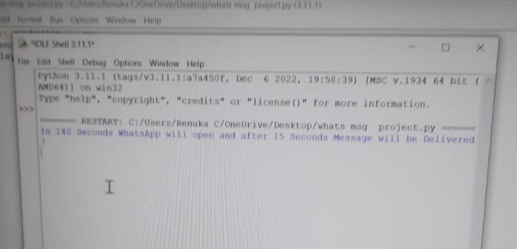

**1.6 Conclusion:**

**We achieve simpliest way to send premsgs to ur beloved onces. In these we can give phone no,msgs,hour,min.Here we set time before only and send them in that time only the msg was sent to opposite person.Like this we sent msgs in insta,sent videos in youtube,google etc,.**